Module 3) HTML

**1 Are the HTML tags and elements the same thing?**

HTML tags and elements are not the same thing.

HTML tags are the starting and ending parts of an HTML element. They begin with < symbol and end with > symbol.

Whatever written inside < and > are called tags.

**2 What are tags and attributes in HTML?**

HTML tags are used to define the structure and content of a web page. They are enclosed in angle brackets, such as <html>, <head>, <body>, etc.

HTML attributes provide additional information about HTML elements. They are always specified in the start tag and usually come in name/value pairs like: **name="value**". Attributes provide extra information about elements such as links, images, styles, and languages.

**3 What are void elements in HTML? With Example.**

There is a special group of elements that only have start tags and does not contain any content within it, these elements are called void elements.

Void elements doesn’t have ending tags and can only have attributes but do not contain any kind of content.

Example of such elements are <br>, <hr>, <img>, <input>, <link>, <base>, <meta>, <param>, <area>, <embed>, <col>, <track>, <source> etc.

**4 What are HTML Entities? With Example.**

HTML entities are used to display reserved characters, special characters, or invisible characters12. For example, < and > are the HTML entities used to display < and > respectively2. If you use less than (<) or greater than (>) symbols in your text, the browser can mix them with tags that's why character entities are used in HTML to display reserved characters1. HTML entities provide a wide range of characters which can allow you to add icons, geometric shapes, mathematical operators, etc1.

**5 What are different types of lists in HTML? With Example.**

Unordered list: An unordered list is created using the <ul> tag. Each item in the list is created using the <li> tag. The items are marked with bullets by default. Here is an example of an unordered list:

<ul>

<li>Item 1</li>

<li>Item 2</li>

<li>Item 3</li>

</ul>

Ordered list: An ordered list is created using the <ol> tag. Each item in the list is created using the <li> tag. The items are marked with numbers by default. Here is an example of an ordered list:

<ol>

<li>First item</li>

<li>Second item</li>

<li>Third item</li>

</ol>

**6 What is the ‘class’ attribute in HTML? With Example.**

The class attribute in HTML is used to specify a class for an HTML element. Multiple HTML elements can share the same class. The class attribute is often used to point to a class name in a style sheet.

<!DOCTYPE html>

<html>

<head>

<style>

.city {

  background-color: tomato;

  color: white;

  border: 2px solid black;

  margin: 20px;

  padding: 20px;

}

</style>

</head>

<body>

<div class="city">

  <h2>London</h2>

  <p>London is the capital of England.</p>

</div>

<div class="city">

  <h2>Paris</h2>

  <p>Paris is the capital of France.</p>

</div>

<div class="city">

  <h2>Tokyo</h2>

  <p>Tokyo is the capital of Japan.</p>

</div>

</body>

</html>

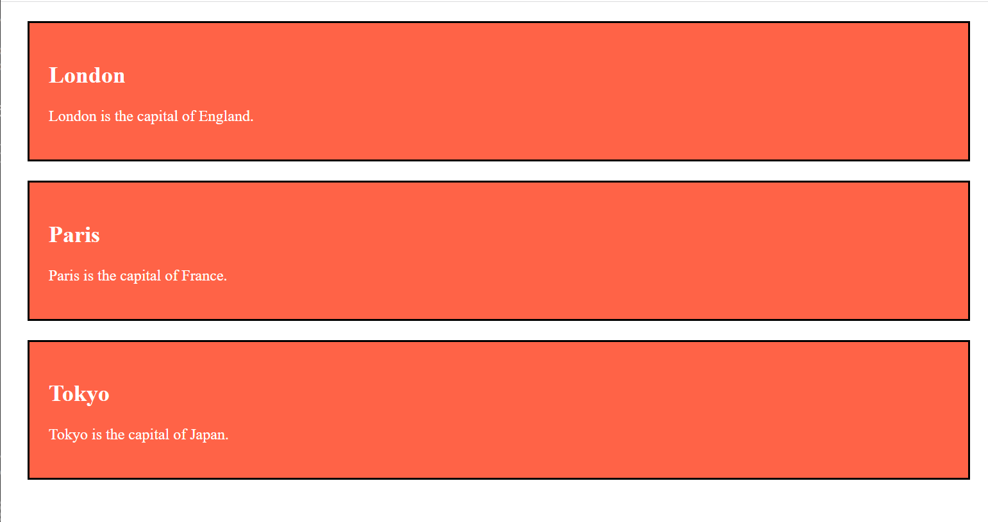

**7 What is the difference between the ‘id’ attribute and the ‘class’ attribute of HTML elements? With Example.**The id and class attributes are used to identify HTML elements.

The main difference between them is that the id attribute is unique and can only be applied to one element,

while the class attribute can be applied to multiple elements.

<!DOCTYPE html>

<html>

<head>

    <title>Example</title>

    <style>

        #unique {

            color: red;

        }

        .common {

            color: blue;

        }

    </style>

</head>

<body>

    <h1 id="unique">This heading has a unique ID</h1>

    <p class="common">This paragraph has a common class</p>

    <p class="common">This paragraph also has a common class</p>

</body>

</html>

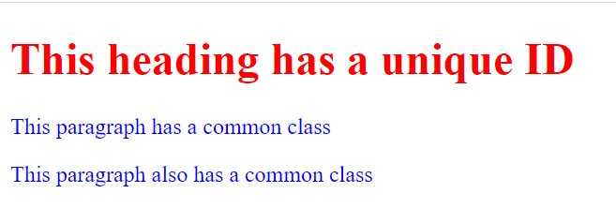

**8 What are the various formatting tags in HTML?**Bold text: The <b> tag is used to define bold text. Example: <b>This text is bold</b>.

Italic text: The <i> tag is used to define italic text. Example: <i>This text is italic</i>.

Underlined text: The <u> tag is used to define underlined text. Example: <u>This text is underlined</u>.

**9 How is Cell Padding different from Cell Spacing? With Example.**

Cell Padding and Cell Spacing are two important attributes of the HTML <table> tag that help in formatting the table.

Cell Padding specifies the space between the border of a table cell and its contents, i.e., it defines the whitespace between the cell edge and the content of the cell. On the other hand, Cell Spacing specifies the space between cells, i.e., it defines the whitespace between the edges of the adjacent cells.

<!DOCTYPE html>

<html>

<head>

<style>

table, th, td {

  border: 1px solid black;

  border-collapse: collapse;

}

th, td {

  padding: 15px;

  text-align: left;

}

</style>

</head>

<body>

<table style="width:100%">

  <tr>

    <th>First Name</th>

    <th>Last Name</th>

    <th>Age</th>

  </tr>

  <tr>

    <td>Jill</td>

    <td>Smith</td>

    <td>50</td>

  </tr>

  <tr>

    <td>Eve</td>

    <td>Jackson</td>

    <td>94</td>

  </tr>

  <tr>

    <td>John</td>

    <td>Doe</td>

    <td>80</td>

  </tr>

</table>

</body>

</html>

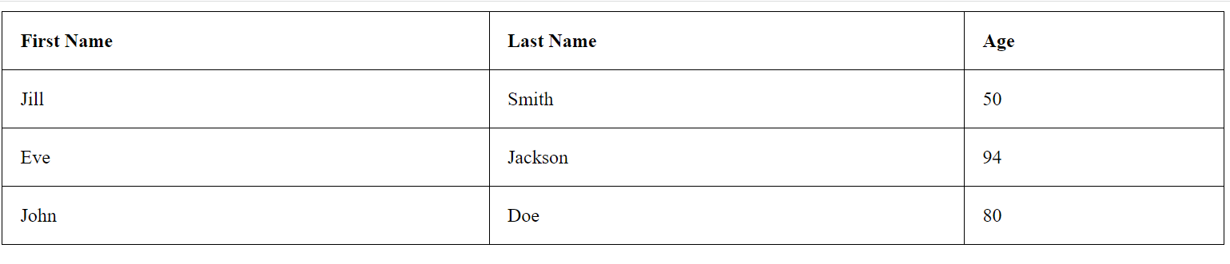

**10 How can we club two or more rows or columns into a single row or column in an HTML table? With Example.**

To merge two or more table cells in a column, use the colspan attribute in a HTML tag. To merge two or more row cells, use the rowspan attribute1.

For example, to merge three cells in a row, set the rowspan=33. Here is an example of how to use colspan to merge cells in a table.

**11 What is the difference between a block-level element and an inline element?**

|  |  |
| --- | --- |
| **Block level element** | **Inline element** |
| Begins in new line of text. | Text is placed on the same line. |
| Its width extends beyond the inner content | Its width only extends as far as the inner content |
| You can set the width and height value | You can’t set width and hights values |

**12 How to create a Hyperlink in HTML? With Example.**The HTML <a> tag defines a hyperlink. It has the following syntax:

<a href="url">link text</a>

<!DOCTYPE html>

<html lang="en">

<head>

    <meta charset="UTF-8">

    <meta name="viewport" content="width=device-width, initial-scale=1.0">

    <title>Document</title>

</head>

<body>

    <a href="Screenshot (5).png">HOME

    </a>

</body>

</html>

**13 What is the use of an iframe tag? With Example.The **iframe** tag is used in HTML to embed another HTML document within the current HTML document. It is an inline frame that can be used to display a web page within a web page. Here is an example of how to use the **iframe** tag:**

<!DOCTYPE html>

<html>

  <head>

    <title>Example of iframe tag</title>

  </head>

  <body>

    <h1>Example of iframe tag</h1>

    <p>Here is an example of how to use the iframe tag:</p>

    <iframe src="https://www.example.com" title="Example website"></iframe>

  </body>

</html>

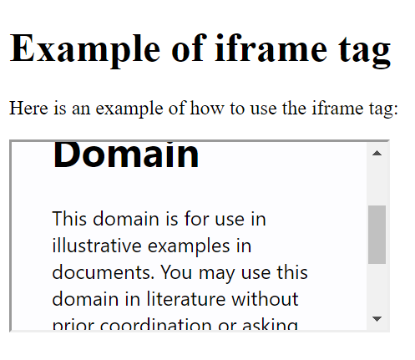

**14 What is the use of a span tag? Explain with example?**

The <span> tag is an inline container used to mark up a part of a text, or a part of a document. It is much like the <div> element, but <div> is a block-level element and <span> is an inline element 1. The <span> tag is easily styled by CSS or manipulated with JavaScript using the class or id attribute.

**15 How to insert a picture into a background image of a web page? With Example.**

To add a picture to the background of a web page, you can use the CSS background-image property. Here is an example of how to add a background image to an HTML element

<!DOCTYPE html>

<html>

<body>

    <h2>Welcome To empire</h2>

<p>bgmi

        <span style="color:red;font-weight:bolder">

            Ankit</span> empire

        <span style="background-color: lightgreen;">Army</span>.

    </p>

</body>

</html>

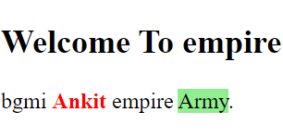

**16• How are active links different from normal links?**

**Active links and normal links are two types of links that are used in websites to point users to different resources. Normal links are also known as unvisited links, and they are displayed in blue color and underlined by default. When a user clicks on a normal link, it changes to a purple color and underlined, indicating that the user has visited the link before. Active links, on the other hand, are temporary and change to red and underlined when the user holds the mouse button on the link and not released yet or if right-clicked on it. Active links show that the browser is in the process of loading a new resource .**

**17 • What are the different tags to separate sections of text?**

There are three tags to seprate section of text.

<br>

<p>

<Blockquote>

**18 What is SVG?**

SVG stands for Scalable Vector Graphics

SVG is used to define graphics for the Web

SVG is a W3C recommendation

The HTML <svg> Element

The HTML <svg> element is a container for SVG graphics.

SVG has several methods for drawing paths, boxes, circles, text, and graphic images.

**19 What is difference between HTML and XHTML?**

| **HTML** | **XHTML** |
| --- | --- |
| **Introduction (from Wikipedia)** | HTML or HyperText Markup Language is the main markup language for creating web pages and other information that can be displayed in a web browser. | XHTML (Extensible HyperText Markup Language) is a family of XML markup languages that mirror or extend versions of the widely used Hypertext Markup Language (HTML), the language in which web pages are written. |
| **Filename extension** | .html, .htm | .xhtml, .xht, .xml, .html, .htm |
| **Internet media type** | text/html | application/xhtml+xml |
| **Developed by** | W3C & WHATWG | World Wide Web Consortium |
| **Type of format** | Document file format | Markup language |
| **Extended from** | SGML | XML, HTML |
| **Stands for** | HyperText Markup Language | Extensible HyperText Markup Language |
| **Application** | Application of Standard Generalized Markup Language (SGML). | Application of XML |
| **Function** | Web pages are written in HTML. | Extended version of HTML that is stricter and XML-based. |
| **Nature** | Flexible framework requiring lenient HTML-specific parser. | Restrictive subset of XML and needs to be parsed with standard XML parsers. |
| **Origin** | Proposed by Tim Berners-Lee in 1987. | World Wide Web Consortium Recommendation in 2000. |
| **Versions** | HTML 2, HTML 3.2, HTML 4.0, HTML 5. | XHTML 1, XHTML 1.1, XHTML 2, XHTML 5. |
|  |  |  |

**20 What are logical and physical tags in HTML?**

**Logical tags are used to display the text according to the logical styles. Some commonly used logical tags include:**

<abbr>: Defines an abbreviation.

<acronym>: Defines an acronym.

<address>: Defines an address element.

<cite>: Defines citation.

<code>: Defines computer code text.

<blockquote>: Defines a long quotation.

<del>: Defines deleted text.

<dfn>: Defines a definition term.

<ins>: Defines inserted text.

<kbd>: Defines keyboard text.

<pre>: Defines preformatted text.

<q>: Defines short quotation.

<samp>: Defines sample computer code.

<strong>: Defines strong text.

<var>: Defines a variable.

**Physical tags are used to provide actual physical formatting to the text. Some commonly used physical tags include:**

<b>: Defines bold text.

<big>: Defines big text.

<i>: Defines italic text.

<small>: Defines small text.

<sup>: Defines superscripted text.

<sub>: Defines subscripted text.

<tt>: Defines teletype text.

<u>: Defines underlined text.